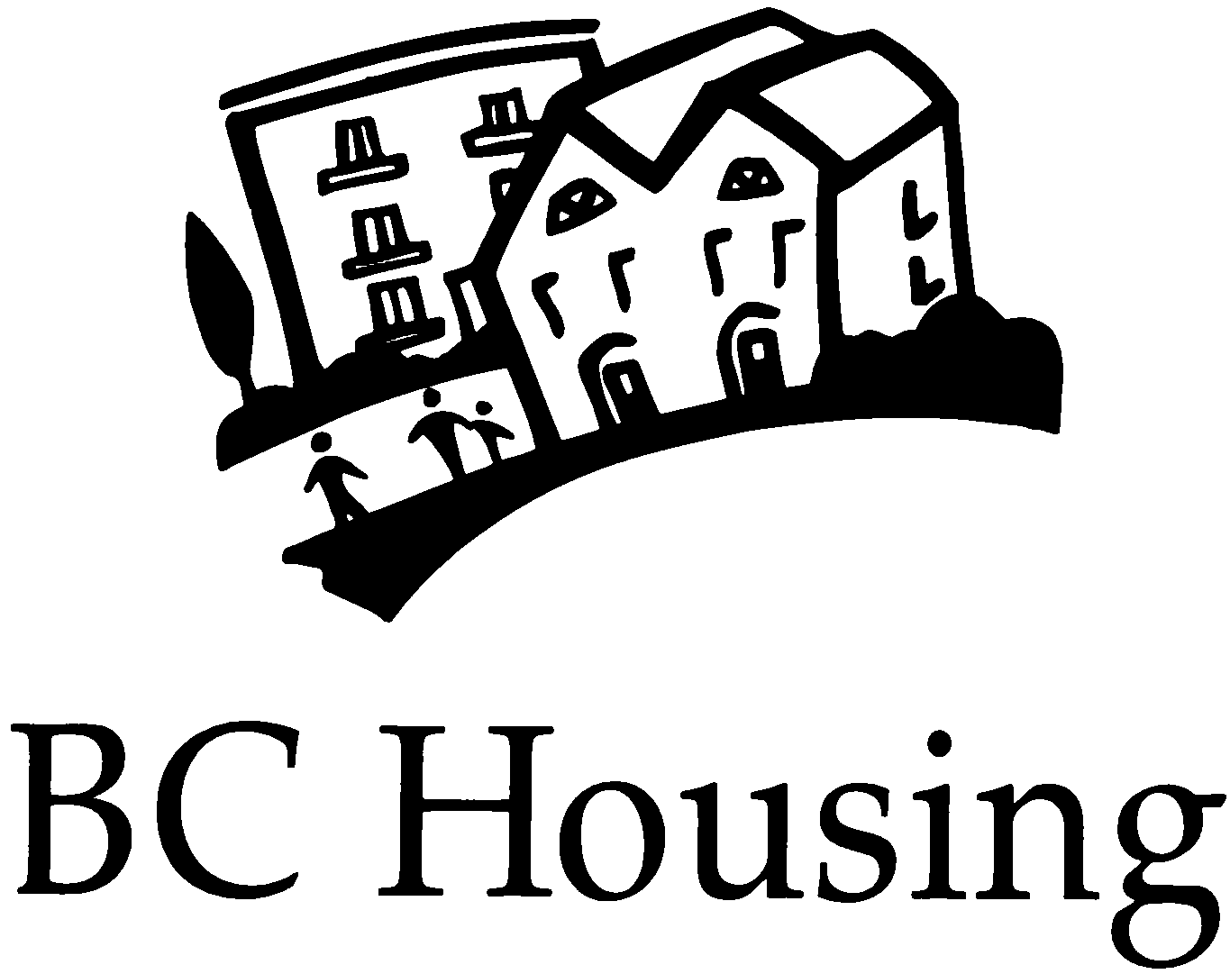

HOUSING PROVIDER ANNUAL INFORMATION FORM

Housing Provider (Sponsor):  (S: |  |  |  | Sponsor #:
Mailing Address:
E-Mail Address:

 | Contacts:
 | Name  (Receives BC Housing Correspondence) |  | Title/  Position |  | Telephone & Cell Phone |  | Fax
1.
2.

 | Board of Directors:
 | Name |  | Title |  | Address |  | Telephone

Management Letter:
Has your auditor provided your board of directors with a management letter? Yes  No 
If “yes”, please attach a copy of the letter to this form and return it to BC Housing.

Information for The Link
BC Housing's Directory of Affordable Housing
SECTION 1 (If BC Housing maintains your applicant list than skip to section 2)
a) | Do you maintain an applicant list? |  |  |  |  |  |  |  | Yes  |  |  |  |  | No 
b) | What is the best way for an applicant to contact you for an application?
 | ❒ | Mail
 |  | Street Address for mail-in applications
 |  | City, Postal Code for mail-in applications
 | ❒ | By contacting us directly: | Phone  |  |  |  |  |  | Fax 
 | ❒ | By coming to your  development or  office in person.
 | Name of your Development:
 | Development Street Address & City:
 | Office Street Address & City:
 | Development's closest major intersection:
 | What are your office hours?
c) | Do you have an application update process? |  |  |  |  |  |  | Yes  |  |  | No 
 | How often should an applicant contact you?
 | How many applications do you keep on file?
 | Are applications cancelled after a number of months? |  |  |  |  |  |  | Yes  |  |  |  | No 
 | If yes, after how many months? _____________________
d) | Does your development allow pets? |  |  |  |  |  |  | Yes  |  |  |  | No 
d) | If yes, are there any restrictions? |  |  |  |  |  |  | Yes  |  |  |  | No 
 | What are the pet restrictions?
 | Are tenants/members required to pay any additional costs (i.e. parking or hydro)? |  |  |  |  |  |  | Yes  |  |  |  | No 
 | If yes, what are the costs associated with?
 | Is a damage deposit required? |  |  |  |  |  |  | Yes  |  |  |  | No 
e) | Does your development have a residency requirement (i.e. applicant must have lived in BC for 6 months)?  If yes, how many months? |  |  |  |  |  |  | Yes  |  |  |  | No 

SECTION 2
f) | Does your development have bachelor or 1 bedroom suites? |  |  |  |  |  | Yes  |  | No 
 | Is there a minimum age requirement? |  |  |  | Yes  |  |  | No 
 | If yes, what age?
 | If yes, are applications under the minimum age requirement accepted if the applicant is disabled? |  |  |  |  | Yes  |  | No 

SECTION 3
g) | For co-ops only:  Does your co-op have a participation requirement? |  |  | Yes  |  | No 
Signature: |  |  | Date:
Thank you for your participation.

